DETERMINATION OF UNKNOWN IMPEDANCE

Objective: To determine the impedance of the given load.

List of Components:
1. Microwave source with square wave modulation
2. Isolator
3. Variable attenuator
4. Detector
5. VSWR meter
6. Slotted line
7. Matched Termination
8. Slide screw Tuner.

Theory:
The unknown terminating impedance can be determined by measuring standing wave ratio & distance of a convenient maxima or minima from the load. Normally for distance measurement minima is used because it is more sharply defined. The unknown load admittances is given by the transmission equation as

where, S = VSWR
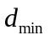= distance of first minima from the load.

A screw projecting into the waveguide offers variation in the admittance with the insertion of the screw. The depth of screw, changes only the reactive part of the admittance, so if the line is matched, the load offered by the screw for a certain depth is
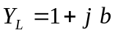
where b is the susceptance due to the screw. The unknown impedance can also be determined by using chart, once the VSWR and position of minima is known with the load.

Procedure:
VSWR
meter

Detector

Microwave source with square wave modulation

Isolator
Variable Attenuator

Slotted Line

Load

Fig 1. Experimental arrangement for measuring impedance

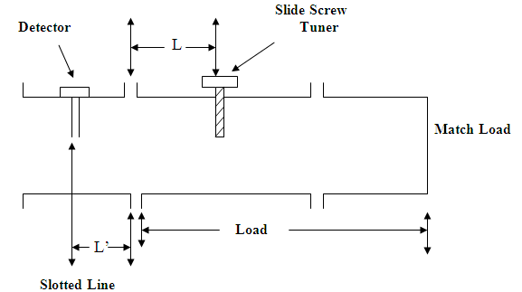

Fig 2. Impedance Measurement

- Set up the circuit as shown in the fig1.
- Terminate the waveguide with a sliding screw & a matched load as shown.
- Fix the position of the screw as close to AA’ as possible. Measure ‘L’ and do not change ‘L’ throughout the experiment.
Insert screw in the waveguide. Note its depth of penetration on the micrometer scale.
- Read VSWR in the meter by adjusting reading at maxima to full scale.
- Locate the position of any minima form AA’.
- To find
L + L’ = + nλ_{g}/ 2,
where, L’ – minima position on the slotted line from
AA’ and n is an integer.
- Now 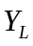 the load admittance is given by
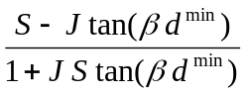

where 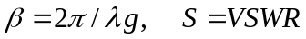
- Repeat for various insertion.
- Now keep screw at certain fix depth and change frequency. For each frequency find S and.
- Plot a curve between depth of insertion and the reactive part of admittance.
- Plot a curve between frequency and reactive part for a particular depth of insertion.

Discussion
- Explain qualitatively the impedance variation with the depth of screw and with frequency?
- The smith chart calculations and the transmission line equation calculations for impedance are valid under what mode conditions?

References:
- S. Ramo, J.R. Whinney and I. VanDuzer, Fields and Waves in Communication Electronics, Third Edition, John Wiley & Sons, 1994.
- E.L. Ginzton: Microwave Measurements, McGraw-Hill Book Company, Inc. New York, 1957.
- Annapurna Das, Sisir K Das, Microwave Engineering, McGraw-Hill International Edition, Singapore, 2000.
- C. G. Montgomery, Techniques of Microwave Measurements, McGraw-Hill, New York, 1947.
- Terman and Petit, “Electronic Measurement”, McGraw-hill Book Co, New York, 1952.

